**Lab Exercise 1- Arduino Blink LED – Circuit and Code**

The Arduino blink LED circuit is a simple circuit that works great for starting to learn Arduino. Both the code and the connections are straightforward so that you can understand it with little to no background.

**Requirement:**

* Arduino Uno
* Breadboard (and some breadboard wires)
* Light-Emitting Diode (LED) (Most LEDs will work)
* Resistor (220 Ω)

**Arduino Blink LED Circuit**

To connect an LED to an Arduino, you need a resistor in series with the LED. This is to limit how much current the LED pulls out of the Arduino pin. The value isn’t crucial but should be between 220 Ω and 1000 Ω.

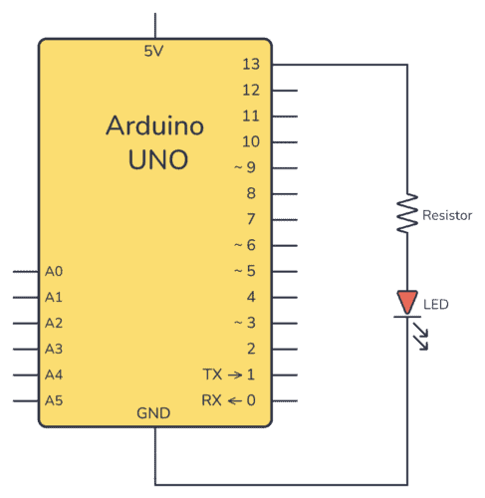

**Connecting On a Breadboard**

Here’s how you can connect the LED and the resistor to the Arduino by using a breadboard and a couple of cables:

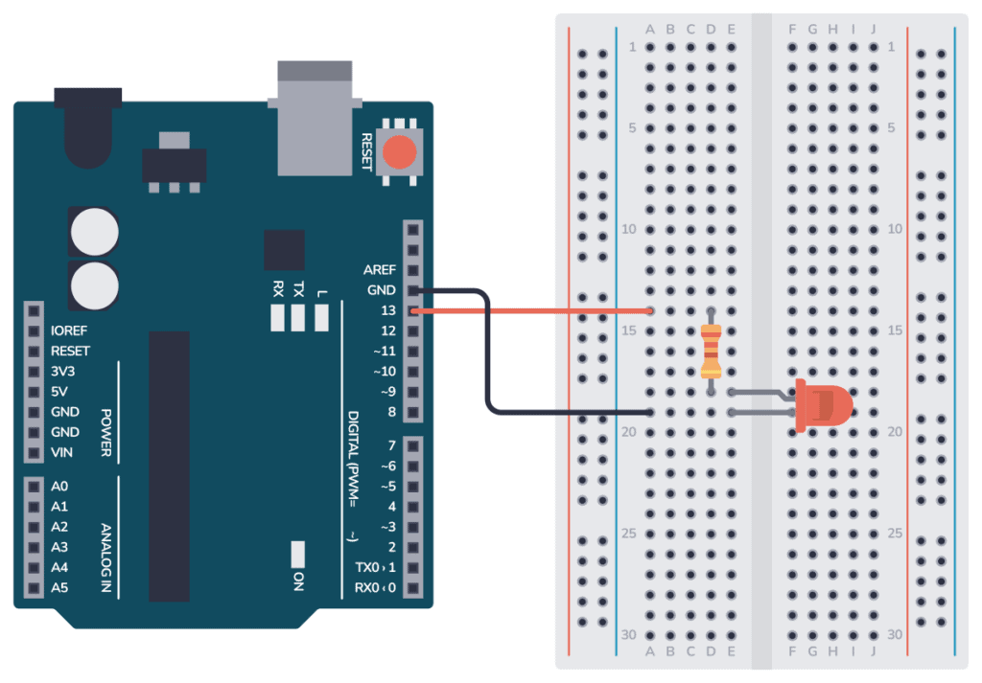

**Arduino Blink LED Code**

* All Arduino code is structured around the two main functions **setup()** and **loop()**.
* The **setup()** function runs only once when the Arduino board starts up. It is used for initializing variables, pins, and other settings.
* The **loop()** function runs repeatedly after the setup() function has been executed. Whatever code is inside this function will be executed over and over again in an endless loop until the Arduino is powered off or reset.
* Inside **setup()**, you need to configure pin 13 as an output.
* Bottom of Form
* Inside **loop()**, you need to set pin 13 HIGH, wait for a second, turn it low, then wait for another second.

**code:**

void setup() {

pinMode(13, OUTPUT);

}

void loop() {

digitalWrite(13, HIGH);

delay(1000);

digitalWrite(13, LOW);

delay(1000);

}

**How the Code Works:**

Inside the **setup()** function there is only one line: pinMode(13, OUTPUT); This line sets pin 13 as an output so that we can use it to turn the LED on or off.

Inside the loop() function there are four lines:

* digitalWrite(13, HIGH); This line turns on the LED connected to pin 13. HIGH sets the voltage of the pin to the logic HIGH level (usually 5V on most Arduino boards), which turns on the LED.
* delay(1000); This line adds a delay of 1000 milliseconds (1 second). It means the LED will remain on for one second before moving on to the next line of code.
* digitalWrite(13, LOW); This line turns off the LED by setting the voltage level of pin 13 to LOW (0V).
* delay(1000); This line adds another 1-second delay. So after the LED is turned off, the program waits for one second.

After this, the program goes back to the beginning of the loop() function where it turns the LED on again, and the process repeats.

This code results in a LED (connected to pin 13) blinking on and off repeatedly, with each state (on and off) lasting for one second.